ECON300 Exam 2 Key

NAME: ____ ___ ID: __________________

I. Multiple Choices (2 pts each, total is 34 pts).
1) If a consumer always buys goods rationally, then
A) the total utilities of the different goods consumed will be equal.
B) the average utilities of the different goods consumed will be equal.
C) the marginal utility per dollar spent on all goods will be equal.
D) the marginal utility of the different goods consumed will be equal.

2) The demand curve for a Giffen good is
A) non-linear but downward-sloping.
B) vertical.
C) upward-sloping.
D) non-existent.

3) We can derive the market demand curve for gold earrings
A) only if the tastes of all gold earring consumers are similar.
B) by adding horizontally the individual demand curves of each gold earring consumer.
C) by adding vertically the quantity demanded of each gold earring consumed at each price.
D) by adding the prices each gold earring consumer is willing to pay for each quantity.

4) If 50 units are sold at a price of $20 and 80 units are sold at a price of $15, what is the absolute value of the price elasticity of demand? Use the midpoint formula.
A) 0.17
B) 0.62
C) 1.62
D) 5

5) If demand is perfectly inelastic, the absolute value of the price elasticity of demand is
A) zero.
B) less than one.
C) more than one.
D) equal to the absolute value of the slope of the demand curve.

6) Price elasticity of demand measures
A) how responsive suppliers are to price changes.
B) how responsive sales are to changes in the price of a related good.
C) how responsive quantity demanded is to a change in price.
D) how responsive sales are to a change in buyers' incomes.

7) Golda Rush quit her job as a manager for Home Depot to start her own hair dressing salon, Goldilocks. She gave up a salary of $40,000 per year, invested her savings of $30,000 (which was earning 5 percent interest) and borrowed $10,000 from a close friend, agreeing to pay 5 percent interest per year. In her first year, Golda spent $18,000 to rent a salon, hired a part-time assistant for $12,000 and incurred another $15,000 on equipment and hairdressing material. Based on this information, what is the amount of her explicit costs?
A) $45,000
B) $45,500
C) $47,000
D) $87,000

8) Vipsana's Gyros House sells gyros. The cost of ingredients (pita, meat, spices, etc.) to make a gyro is $2.00. Vipsana pays her employees $60 per day. She also incurs a fixed cost of $120 per day. Calculate Vipsana's variable cost per day when she produces 50 gyros using two workers?
A) $100
B) $124.40
C) $220
D) $240

9) Jennifer Borts moves her office from the premises she rents at a local mall to her home. As a result of this move
A) Jennifer's explicit costs fall and her implicit costs rise.
B) Jennifer's total costs fall.
C) Jennifer's implicit costs fall.
D) Jennifer's opportunity costs fall.

10) Which of the following statements is true?
A) Opportunity cost = explicit cost - implicit cost.
B) Total cost = fixed cost + implicit cost.
C) Total cost = fixed cost + variable cost.
D) Variable cost = wages + salaries + benefits.

11) Red Stone Creamery currently hires 5 workers. When it added a 6th worker, its output actually fell. Which of the following statements is true?
A) The marginal product of the sixth worker must be negative.
B) The average product of the sixth worker is negative.
C) The sixth worker is not as skilled as the fifth worker.
D) The total product becomes negative.

12) The law of diminishing marginal returns states
A) that at some point, adding more of a fixed input to a given amount of variable inputs will cause the marginal product of the variable input to decline.
B) that at some point, adding more of a variable input to a given amount of a fixed input will cause the marginal product of the variable input to decline.
C) that in the presence of a fixed factor, at some point average product of labor starts to fall as more and more variable inputs are added.
D) average total costs of production initially fall and after some point starts to rise at a decreasing rate as output increases.

13) A perfectly competitive firm produces 3,000 units of a good at a total cost of $36,000. The price of each good is $10. Calculate the firm's short-run profit or loss.
A) loss of $6,000
B) profit of $6,000
C) profit of $30,000
D) There is insufficient information to answer the question.

14) For a perfectly competitive firm, which of the following is not true at profit maximization?
A) Market price is greater than marginal cost.
B) Marginal revenue equals marginal cost.
C) Total revenue minus total cost is maximized.
D) Price equals marginal cost.

15) To maximize profit, a perfectly competitive firm
A) should sell the quantity of output determined by the interaction between industry demand and supply.
B) should sell the quantity of output that results in a value for total revenue that is equal to total cost.
C) should produce the quantity of output that results in the greatest difference between total revenue and total cost.
D) should produce the quantity of output that results in the greatest difference between marginal revenue and marginal cost.

Figure 7-7
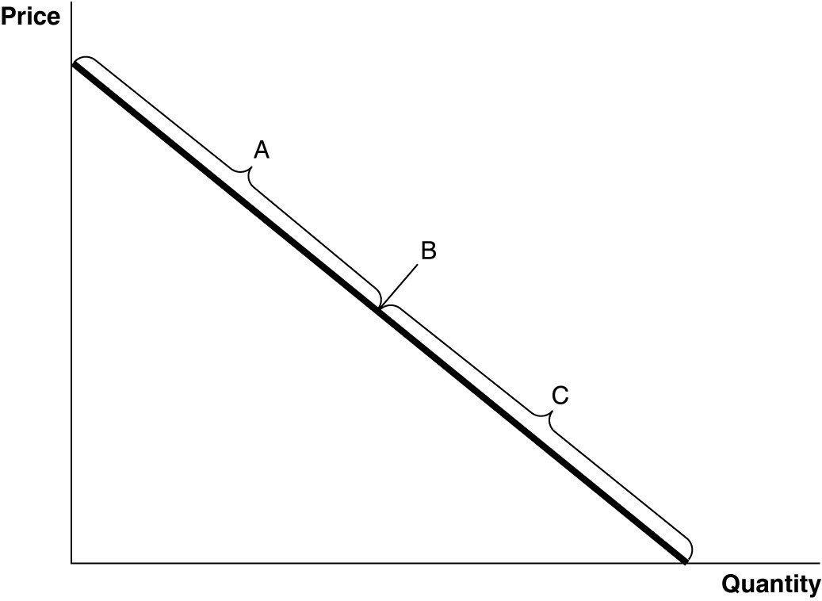

16) Refer to Figure 7-7. The section of the demand curve labeled "A" represents
A) the inelastic section of the demand curve.
B) the unit-elastic section of the demand curve.
C) the elastic section of the demand curve.
D) the perfectly elastic section of the demand curve.

17) If production displays economies of scale, the long-run average cost curve is
A) above the short-run average total cost curve.
B) downward-sloping.
C) upward sloping.
D) below the long-run marginal cost curve.

II. Essays (total is 66 pts)

Table 7-5
Quantity of Burgers | Marginal Utility | Quantity of Pepsi | Marginal Utility | MUb/Pb | MUp/Pp
1 | 20 | 1 | 30 | 10 | 30
2 | 14 | 2 | 10 | 7 | 10
3 | 10 | 3 | 7 | 5 | 7
4 | 3 | 4 | 5 | 3/2 | 5
5 | 1 | 5 | 1 | ½ | 1
6 | -5 | 6 | 0 | -5/2 | 0
7 | -10 | 7 | -4 | -5 | -4

Table 7-5 lists Jay's marginal utilities for burgers and Pepsi. Jay has $10 to spend on these two goods. The price of a burger is $2 and the price of a can of Pepsi is $1.
1). Refer to Table 7-5. What is Jay's optimal consumption bundle? (4 pts)

- Jay's optimal consumption bundle is 3 burgers and 4 cans of Pepsi

2). Refer to Table 7-5. If Jay can eat all the Pepsi he wants for free, how many cans will he consume? (4 pts)

- He will consume 5 cans

Table 7-9
 | Estimated Price Elasticity of Demand
Coca-Cola | -3.0
All carbonated soft drinks | -1.5
All soft drinks | -0.8

3. Refer to Table 7-9. Assume that an economist has estimated the price elasticity of demand values in the table above. Use the data in the table to select the correct statement. (4 pts)
A) The demand for Coca-Cola is inelastic.
B) The elasticity for "All soft drinks" is less than the elasticity for Coca-Cola because Coca-Cola is more of a luxury than a necessity; "All soft drinks" represent goods that are more necessity than luxury.
C) The difference in elasticity values is explained by the fact that the more narrowly we define a market the more elastic the demand will be.
D) There are fewer substitutes for "All carbonated soft drinks" than there are for "All soft drinks."

4. Consider a firm in a perfectly competitive market. Fill in the columns in the following table (10 pts) and use the values in the table to determine the profit-maximizing level of output (4 pts). (total is 14 pts)

Quantity | Total Revenue (TR) | Total Cost (TC) | Profit | Marginal Revenue (MR) | Marginal Cost (MC)
0 | 0 | 3 | -3 | ----- | -----
1 | 4 | 5 | -1 | 4 | 2
2 | 8 | 6 | 2 | 4 | 1
3 | 12 | 8 | 4 | 4 | 2
4 | 16 | 11 | 5 | 4 | 3
5 | 20 | 15 | 5 | 4 | 4
6 | 24 | 21 | 3 | 4 | 6
7 | 28 | 30 | -2 | 4 | 9
8 | 32 | 42 | -10 | 4 | 12
9 | 36 | 60 | -24 | 4 | 18
10 | 40 | 85 | -45 | 4 | 25

- The profit-maximizing level of output is 5 units

Table 7-13
Price of Streaming  Service | Subscriptions Sold at That  Price | Total Revenue at That Price
$12.99 | 500,000 | $6,495,000
10.99 | 650,000 | 7,143,500
5. Refer to Table 7-13. Based on the data in the table, between a price of $10.99 and $12.99, determine if the demand for streaming service is elastic, inelastic, or unit elastic. (4 pts)

- The demand for streaming service is elastic
6. Refer to Table 7-13. Based on the data in the table and using the midpoint formula, between a price of $10.99 and $12.99, find the price elasticity of demand for streaming service. (4 pts)
- The price elasticity of demand for streaming service is -1.56

7. Figure 9-1(4 pts each, total is 16 pts)
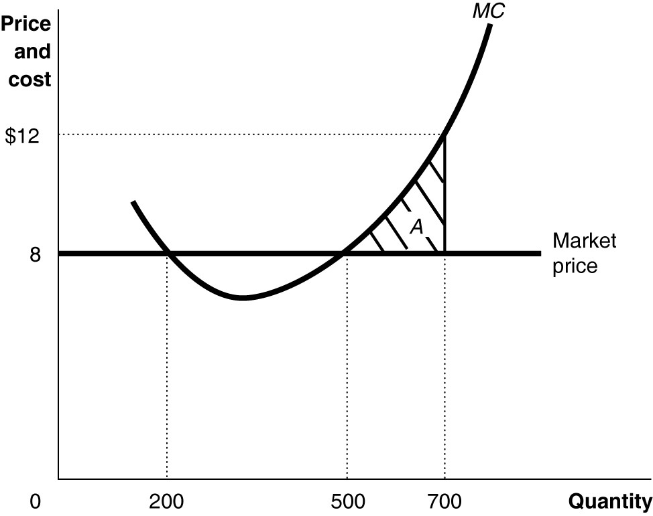

a) Refer to Figure 9-1. If the firm is producing 700 units, is it maximizing its profit? If not, how should the firm improve its profit?

- It is not maximizing its profit. The firm should reduce its output to improve its profit

b) Refer to Figure 9-1. If the firm is producing 200 units, is it maximizing its profit? If not, how should the firm improve its profit?

- It is not maximizing its profit. The firm should increase its output to improve its profit

c) Refer to Figure 9-1. If the firm is producing 500 units, is it maximizing its profit? If not, how should the firm improve its profit?

- It is maximizing its profit

d) Refer to Figure 9-1. If the firm is charging a price of $12 per unit, what is the quantity the firm sell?
- The quantity the firm sell is 0

Table 8-7 (4 pts each, total 16 pts)
Quantity of Lanterns | Fixed Cost (dollars) | Variable Cost  (dollars) | Total Cost  (dollars) | Average Total Cost (dollars) | Marginal Cost (MC)
75 | 200 | 170 | 370 | 4.93 | 370
80 | 200 | 230 | 430 | 5.36 | 60
90 | 200 | 490.3 | 690.3 | 7.67 | 260.3
100 | 200 | 810 | 1010 | 10.1 | 319.7
115 | 200 | 1157 | 1357 | 11.8 | 347
117 | 200 | 1264 | 1464 | 12.5 | 107
120 | 200 | 1480 | 1680 | 14 | 216

Table 8-7 shows cost data for Lotus Lanterns, a producer of whimsical night lights.

8) Refer to Table 8-7. What is the variable cost of production when the firm produces 115 lanterns? (4 pts)

- $1157

9) Refer to Table 8-7. What is the average total cost of production when the firm produces 120 lanterns? (4 pts)

- $14

10) Refer to Table 8-7. What is the marginal cost per unit of production when the firm produces 120 lanterns? (4 pts)

- $216

11) Refer to Table 8-7. What is the total cost of production when the firm produces 90 lanterns? (4 pts)

- $690.3

